Asg 2 COMPSCI 753

Student ID: 964150056

Name: Haolin Feng

UPI: hfen690

Part 1:

1. Average frequency = 4.242

(b)

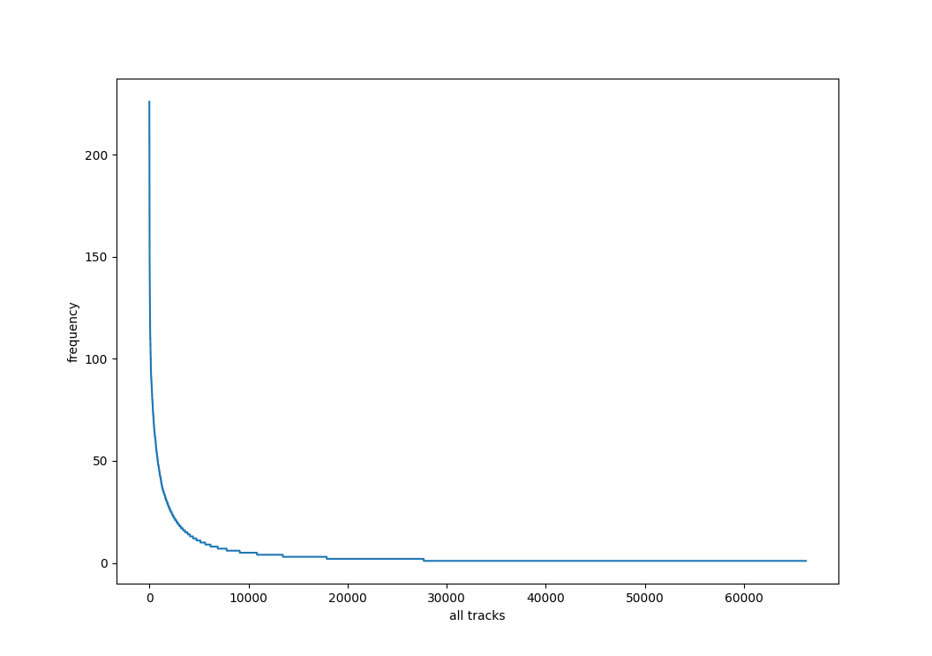

Part II

1. k=5000

图表

(b)

Rank Relative error

1 0.22123893805309736

2 0.22522522522522526

3 0.2325581395348837

4 0.23696682464454977

5 0.24271844660194175

6 0.24752475247524752

7 0.2525252525252525

8 0.25380710659898476

9 0.2551020408163265

10 0.26881720430107525

11 0.2717391304347826

12 0.2777777777777778

13 0.28735632183908044

14 0.29239766081871343

15 0.29239766081871343

16 0.29940119760479045

17 0.30487804878048785

18 0.3125

19 0.3125

20 0.3144654088050315

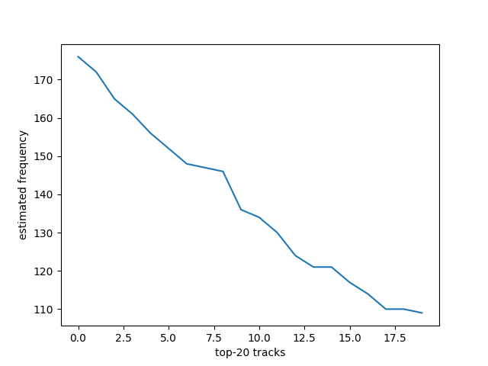

(c)

When k = 5000, number of decrement steps = 50

Part III

1. w = 20000, d = 2,

(b)

(c)

Misra-Gries Approach:

From the result in different k, when k grows larger, the estimation is more accurate and the runtime gets longer with some oscillation on both accuracy and time. When k = 10000, the runtime is the fastest with 0.56 of the average relative error. However, if we wait more 7 seconds by choosing k=15000, we get 0.49 of the average relative error. I would like to pick k=15000 that achieve a considerable accuracy and runtime.

Count Sketch Algorithm:

From the result above, it is obvious that larger w and d give a better estimation but cost more time. I would like to pick w=20000 d=6, k=12000 because it gives a good estimation and does not cost much computation time.

(d) k = 15000

Miisra_Gries Approach:

Broccoli (feat. Lil Yachty) 215 226 0.05

Ignition - Remix 211 222 0.05

Gold Digger 204 215 0.05

No Role Modelz 200 211 0.05

Closer 195 206 0.05

HUMBLE. 191 202 0.05

Jumpman 187 198 0.06

One Dance 186 197 0.06

No Problem (feat. Lil Wayne & 2 Chainz) 185 196 0.06

Bad and Boujee (feat. Lil Uzi Vert) 175 186 0.06

Caroline 173 184 0.06

Congratulations 169 180 0.06

Bounce Back 163 174 0.06

Mr. Brightside 160 171 0.06

Yeah! 160 171 0.06

Bohemian Rhapsody - Remastered 2011 156 167 0.07

Roses 153 164 0.07

679 (feat. Remy Boyz) 149 160 0.07

Fake Love 149 160 0.07

Ni**as In Paris 148 159 0.07

Count Sketch Algorithm:

w = 20000 d = 6

Gold Digger 362 215 0.6837209302325582

Impossible - Main 362 14 24.857142857142858

The Kids (feat. Janelle Monáe) 362 2 180.0

Shangri-La 362 1 361.0

Broccoli (feat. Lil Yachty) 350 226 0.5486725663716814

I Met You 350 2 174.0

Winter Blues 350 1 349.0

No Other Heart 350 1 349.0

No Role Modelz 332 211 0.5734597156398105

Busman's Holiday 332 2 165.0

Inspire Me 332 3 109.66666666666667

German Love 332 1 331.0

Caroline 300 184 0.6304347826086956

Holiday Road - National Lampoon's Vacation 300 1 299.0

Drive-In Movies 300 2 149.0

Thank God I Got It 300 1 299.0

Bad and Boujee (feat. Lil Uzi Vert) 293 186 0.575268817204301

Rollin' (The Ballad Of Big & Rich) - The Ballad Of Big & Rich Album Version 293 4 72.25

The Black and White 293 1 292.0

Cinnamon 293 1 292.0